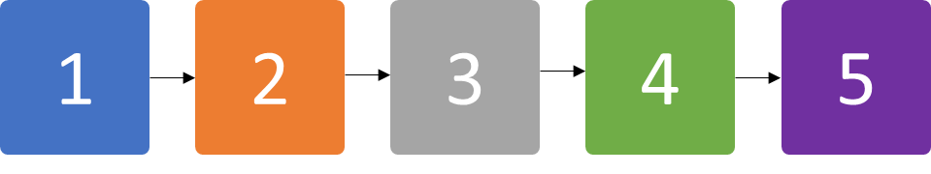Income and expenditure diary 2018

DATE FROM: MONDAY 15th April 2019  
DATE TO: SUNDAY 21st April 2019

**FILL OUT IN THIS ORDER:**



PLEASE FILL OUT AND RETURN TO:

PHONE:

**CORRECTLY AND TRUTHFULLY COMPLETED DIARIES WILL GO INTO A MONTHLY DRAW WHERE 1 IN 10 PEOPLE WILL WIN 30,000 SHILLINGS.**

EACH MONTHLY DIARY COMPLETED IS ONE VALID ENTRY FOR EACH HOUSEHOLD

## Research project details

This diary is to record:

|  |  |  |  |  |
| --- | --- | --- | --- | --- |
| EXPENDITURES | CONSUMPTION | INCOME | COFFEE PICKING | COFFEE SALES |

If you have questions on the diary or on the research please contact:

Mr Julius Njoke: ___________________

If you wish to report any issues on the conduct of this research you can contact the research leaders:

Dr Prossy Isubikalu  
+256 772 345 398  
isubikalu@gmail.com

DETAILS:

Your Name: ________________________________

Your Father’s name: ______________________

Your Mother’s name: _____________________

Village you live in: ________________________

Sub-county you live in: ___________________

Your Phone number: _____________________

How to fill out:

You should aim to fill out this diary each day. It will take you less than 5 minutes of your time each day to fill out.

Fill out an entry with a single vertical mark in the correct box. Each fifth mark should be a horizontal mark as below:

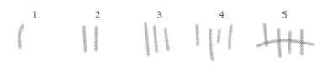

If you have any questions on the meaning of symbols you can consult the rear of this booklet for an explanation. Alternatively you can call the local research manager

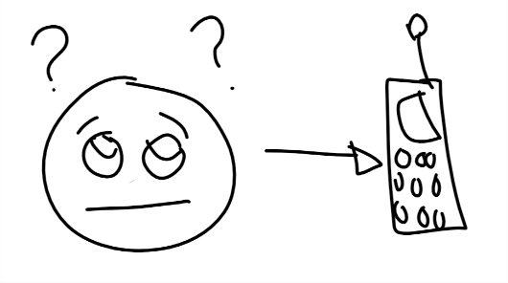

Mr Julius Njoke: _______________________________

Finally, you should answer truthfully. Random checks will be undertaken on the data entered.

Please state the following to the research officer:

“I will seek to enter all details for this diary in an accurate and truthful way”

**Please tally the money you earnt, obtained from others, or used from your savings this week**

|  |  |  |  |  |  |  |
| --- | --- | --- | --- | --- | --- | --- |
|  | C:\Users\Daniel\AppData\Local\Microsoft\Windows\INetCache\Content.MSO\312DE5FA.tmp | Image result for PICTURE UGANDAN SHILLINGS |  |  |  |  |
| C:\Users\Daniel\AppData\Local\Microsoft\Windows\INetCache\Content.MSO\2058485.tmp  Coffee picking |  |  |  |  |  |  |
| Coffee sales |  |  |  |  |  |  |
| Parchment sales |  |  |  |  |  |  |
| OTHER WORK |  |  |  |  |  |  |
|  |  |  |  |  |  |  |
| Image result for couple pngHUSBAND/WIFE |  |  |  |  |  |  |
| **Image result for friends icon**  FRIENDS/OTHER FAMILY |  |  |  |  |  |  |
| SAVINGS |  |  |  |  |  |  |
| WAS REPAID MONEY OWED |  |  |  |  |  |  |
| Gambling |  |  |  |  |  |  |

**Did you ask for any money from friends or family this week?**

YES NO



**Please indicate where your money went this week**

|  |  |  |  |  |  |  |
| --- | --- | --- | --- | --- | --- | --- |
|  | C:\Users\Daniel\AppData\Local\Microsoft\Windows\INetCache\Content.MSO\312DE5FA.tmp | Image result for PICTURE UGANDAN SHILLINGS |  |  |  |  |
| Image result for couple pngHUSBAND/WIFE |  |  |  |  |  |  |
| EXPENSES/ CONSUMPTION |  |  |  |  |  |  |
| SAVINGS |  |  |  |  |  |  |
| Image result for STOLEN MONEY PNGSTOLEN |  |  |  |  |  |  |
| **Image result for friends icon**  FRIENDS |  |  |  |  |  |  |
| LOANS |  |  |  |  |  |  |



**Please indicate your expenses this week**

|  |  |  |  |  |  |  |
| --- | --- | --- | --- | --- | --- | --- |
|  | C:\Users\Daniel\AppData\Local\Microsoft\Windows\INetCache\Content.MSO\312DE5FA.tmp | Image result for PICTURE UGANDAN SHILLINGS |  |  |  |  |
| Image result for food png  FOOD |  |  |  |  |  |  |
| C:\Users\Daniel\AppData\Local\Microsoft\Windows\INetCache\Content.MSO\362BDFA1.tmp  FARM TOOLS |  |  |  |  |  |  |
| FARM INPUTS |  |  |  |  |  |  |
| HOME CONSUMABLES (e.g. lightbulbs, paper, etc.) |  |  |  |  |  |  |
| EDUCATION  (e.g. fees, books, food) |  |  |  |  |  |  |
| Gambling |  |  |  |  |  |  |
| Alcohol, cigarettes |  |  |  |  |  |  |
| Rent/house loan payment |  |  |  |  |  |  |
| Other loan payment |  |  |  |  |  |  |
| Transport |  |  |  |  |  |  |
| Other |  |  |  |  |  |  |



**FOOD CONSUMPTION FOR YOURSELF**

|  |  |  |  |  |  |  |  |
| --- | --- | --- | --- | --- | --- | --- | --- |
|  | **MON** | **TUES** | **WED** | **THUR** | **FRI** | **SAT** | **SUN** |
| MATOOKE |  |  |  |  |  |  |  |
| C:\Users\Daniel\AppData\Local\Microsoft\Windows\INetCache\Content.MSO\72CD30CD.tmp  ROOTS/IRISH/YAMS |  |  |  |  |  |  |  |
| POSHO/RICE/CEREALS |  |  |  |  |  |  |  |
| VEGETABLES |  |  |  |  |  |  |  |
| BEANS |  |  |  |  |  |  |  |
| Image result for FRUIT ICON  FRUIT |  |  |  |  |  |  |  |
| ORGAN MEAT |  |  |  |  |  |  |  |
| MEAT |  |  |  |  |  |  |  |
| EGGS |  |  |  |  |  |  |  |
| DAIRY |  |  |  |  |  |  |  |
| ALCOHOL |  |  |  |  |  |  |  |
| TOBACCO |  |  |  |  |  |  |  |
| SWEETS/SODA/ETC. |  |  |  |  |  |  |  |

 **FOOD CONSUMPTION FOR YOUR HOUSEHOLD**

|  |  |  |  |  |  |  |  |
| --- | --- | --- | --- | --- | --- | --- | --- |
|  | **MON** | **TUES** | **WED** | **THUR** | **FRI** | **SAT** | **SUN** |
| MATOOKE |  |  |  |  |  |  |  |
| C:\Users\Daniel\AppData\Local\Microsoft\Windows\INetCache\Content.MSO\72CD30CD.tmp  ROOTS/IRISH/YAMS |  |  |  |  |  |  |  |
| POSHO/RICE/CEREALS |  |  |  |  |  |  |  |
| VEGETABLES |  |  |  |  |  |  |  |
| BEANS |  |  |  |  |  |  |  |
| Image result for FRUIT ICON  FRUIT |  |  |  |  |  |  |  |
| ORGAN MEAT |  |  |  |  |  |  |  |
| MEAT |  |  |  |  |  |  |  |
| EGGS |  |  |  |  |  |  |  |
| DAIRY |  |  |  |  |  |  |  |
| ALCOHOL |  |  |  |  |  |  |  |
| TOBACCO |  |  |  |  |  |  |  |
| SWEETS/SODA/ETC. |  |  |  |  |  |  |  |